Update Report - March 2024
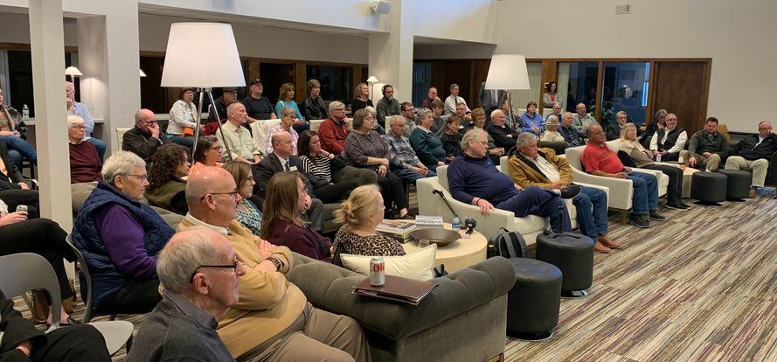
Annual Appreciation Event

First of all, special thanks to Heather Moore of Moore Local for catering our event and for Innovate 120 for graciously hosting our event! ***
Most of you know me, but you probably don’t know me really well. I was in city government for over 26 years, and I know that things take time. We spend time developing partnerships and we do our homework to determine the best ways to move forward. I know that a lot of time is spent on building the foundations for success. That said, I am impatient. I have higher expectations for what Ben, and I should be accomplishing. I like results. Normally I know what the answer is and then just do what I need to do to get there. But economic development isn’t that straightforward, and it isn’t that easy. We need housing at all levels to encourage a movement in the market that makes affordable housing available to increase our workforce. We need jobs but we don’t need jobs that compete with our current employers who are already challenged with finding the workforce that is unique to their workforce needs. We need affordable childcare not only for our businesses and industries but for our school enrollment as well. Families with school-aged children can’t move here if there isn’t childcare for younger siblings. That said, we are embarking on a childcare study starting the first of April. I am hopeful that with all your input, we can come up with solutions. 7,300 of our the 10,500 members of our workforce are over the age of 55 which means we will have 70% of our workforce retiring in the next 10-15 years. There is a lot going on and no easy answers for any of it. I am not saying all that to be doom and gloom. It is just our reality. But I have faith that together we can navigate through this. We can rely on each other’s strengths and talents. We can rely on each other’s support. We can be there to encourage each other and hold each other accountable. We can share our success stories like many of you heard from Robert earlier this evening. Jackson County is full of dedicated, committed, REAL people who share the traditional Midwest values of honesty, integrity and that a man or woman’s word still means something. We can’t do this alone. So thank you, each and every one of you. Together we will continue to make Jackson County a place where we are so very proud to call “Home!” Thank you for investing in your future and the futures of your family and friends.

The 36 partners of the JCEA
We have 36 public and private partners who are committed to funding our initiatives. We all should be grateful for their generosity because although they fund the JCEA, they also are investing in the future of each and every citizen and business who are proud to call Jackson Co their home because everything we do, no matter how big or small, benefits someone or some business. And every individual success is a success for the County. Special thanks to:
Jackson County Board of Supervisors City of Maquoketa
City of Bellevue City of Preston
City of Miles City of Sabula
Maquoketa Municipal Electric Bellevue Municipal Electric
Maquoketa Valley EC Black Hills Energy
Alliant Energy Maquoketa State Bank
Bellevue State Bank US Bank
Fidelity Bank Clinton National Bank
DuTrac Bellevue BETA
Eastern Iowa Community College Precision Metal Works
Plastics Unlimited Jackson County Regional Hospital
Osterhaus Pharmacy Kunau Implement
Origin Design WHKS Engineering
Sonac Blue-9
Imagine the Possibilities Off Shore
Innovate 120 Water Street Partners
Community Foundation of Jackson Co Bellevue Chamber of Commerce
Maquoketa Chamber of Commerce ECIA

This project includes the complete construction of two one-bedroom apartments on the upper story of 172 W Gillet Street in Preston, Iowa. The space is vacant and unlivable. The previous owner had demolished the walls in anticipation of restoring the space into apartments but abandoned the idea when she was unable to receive adequate funding. City records show that this space has not been inhabited for at least 20 years.
This project is vital to Preston for many reasons. As populations continue to decline in rural areas, housing developers are hesitant to invest in new developments. As existing infrastructure continues to deteriorate, existing housing becomes no longer viable. It is essential to rural counties that existing infrastructure is maintained and improved and that quality of life investments are made to incent current residents to stay and new residents to relocate Whether entices current residents to stay or new residents to make Preston their home, it is a win for Preston and Jackson County. We need our residents to support local services, be a part of the workforce to support our existing businesses and be a part of our community to support one another.
JCEA wrote and submitted the pre-app. ECIA will write the final application for submittal.

Preston Catalyst grant pre-approval

Project Hedron is a semiconductor manufacturer who will invest $40M in a facility and employ 74. JCEA received the Request for Information (RFI) on March 7th asking for a response by the EOB on the 8th. One of the qualifications was to be within 10 miles of an interstate. We asked for clarification given the site is less than a mile of HWY 61 which is only 36 miles from I80. This allowed us to meet the preliminary qualifications. We then moved on to the next round which was a comprehensive RFI due by noon on March 14th. Special thanks to Leallen Ehlers and Katie Bopes with EICC, Miranda Swafford and Mandy Tripp of Mississippi Valley Workforce, Christie Remley and Nik Schulte of MREC, Josh Boldt of City of Maquoketa and Amber Rodgers of IEDA for responding to quickly with necessary information to proceed forward. This is a multi-state RFI so the competition is tough. That said, we have affordable, land, utilities, workforce, organizations to train new employees, competitive incentives, and, of course, the culture and natural resources to draw people here and give them a reason to live and work in Jackson County.
Project Hedron RFI – Maquoketa Industrial Park

General Plan
- 2.5 story building -all units with expansive river views, and a garage space included
- Total of 6 units
  - 4 modern upscale living units (think condo or “higher” end apartments
    - 3 top floor units -2bedrooms with open lofts
    - 1 lower floor unit -2bedroom
  - 1 commercial space
  - 1 option space -commercial/residential/ common usage
Initial contact was in 2022. JCEA exchanged many emails between the developer and the City to obtain City approval for the project, city match and coordination with ECIA for the grant application.

Sabula Catalyst Grant pre-app
Approved

BETA was established in 2009 to promote Tourism and Economic Development in Bellevue. In 2019 BETA entered into a development agreement with the City to purchase the Stamp Farm. The background was that there had been an industrial prospect who needed 30 acres of land, but there wasn’t any readily available. A proactive effort was made then to find and purchase land for availability in the future. Around 65 acres was purchased through a mutual agreement between the City, BETA and Bellevue Utilities. The plan was for the City to grant BETA the funds so the land could be purchased. BETA owns the property and can more easily sell parcels without going through the City’s vacation or property proceedings. Initially there was hope that a USDA grant could offset the cost for the utility extensions to the extent that it would make development more feasible. Unfortunately, the 2020 Census revealed that Bellevue no longer qualified for the USDA grant. That news along with COVID and the massive increase in costs, made the extension of utilities cost prohibitive. Options are now being considered for the sale of this land.

Stamp Property – Bellevue Tourism and Economic Association

Future land development
Discussions are continuing and contacts are being made with landowners in and around Bellevue who may be willing to sell their land for future development in Bellevue. Bellevue is in need of land for future residential, commercial and light-industrial.
in Bellevue

Maquoketa Greenspace
Ben chairs the Maquoketa Greenspace Planning Committee and is the Vice-Chair of the Maquoketa Betterment and Hometown Pride Committee. The plans have been finalized other than some smaller details and fundraising is progressing very nicely.
Development

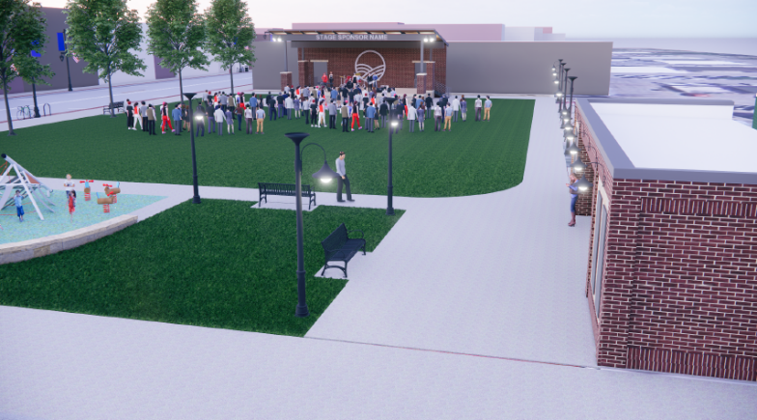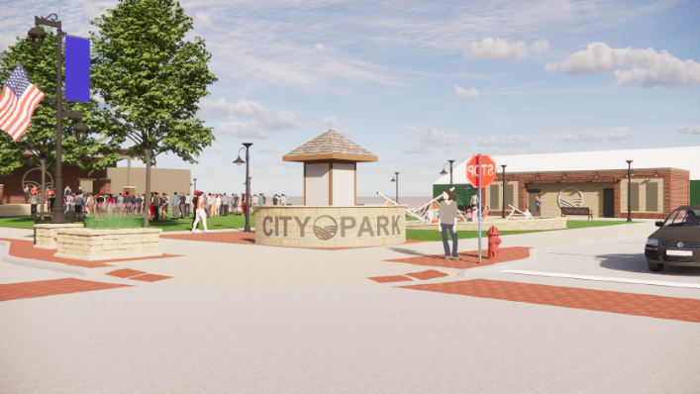

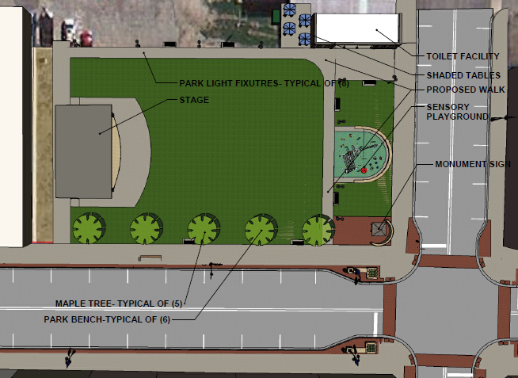
Downtown Incentive Programs
Bellevue, Maquoketa and Preston all have downtown incentive programs that will pay up to a shared amount for improvements in the following areas: Acquisition, Signage, Consultant Assistance, Façade, Commercial Interior, Upper Story Renovation, Conversion of 1st floor from residential to commercial. Cities finance these programs through the use of TIF dollars. TIF means tax increment financing. TIF is used to pay or rebate funds to developers and property owners for improvements and new development resulting in an increase in valuation. The increase in valuation means an increase in tax revenue for the City, County, School District, Community College, County Hospital and other misc items. An increase in valuations is needed for a City to stay financially healthy and to be able to provide the necessary services and cultural amenities people need to feel good about where they live. I encourage all cities to consider putting together an urban renewal plan for your city and developing a downtown incentive program. A healthy downtown promotes a healthy city! EVERYONE WINS!!!

Maquoketa has an urban revitalization program that encourages making those necessary maintenance repairs and improvements to your property. It also encourages the construction of new homes and multi-family dwellings. This plan covers all land that is currently annexed in the City. The improvements must increase the overall value of the property by 10%. The benefits for your investment include a 100% property tax exemption for the first $75,000 of valuation of your property. As stated above, this includes the construction of new homes as well. All new homes get 100% abatement on the first $75,000 of valuation of your home for 5 years!! A residential property with three or more separate dwelling units is eligible to receive property tax abatement for 10 years with the first year abating 80% of your value decreasing over the following 9 years.
Maquoketa Urban Revitalization Program

JCEA receives a few calls and visits each month regarding start-up businesses or business expansions and relocations. It’s always a delicate balance in situations where a national franchise is looking to locate in an area where there is already another national franchise competitor in the area. This also pertains to businesses on a smaller scale where there is already a business with that specialty in our area. We do our best to show opportunities where they are available at all levels and encourage open communication. In general, all of the COVID funding where cash was available for new businesses is gone. There are low interest loans and support and coaching programs available that assist small business owners in getting started and don’t forget – Wednesdays are possible.
Small business development

Wednesdays are possible is a monthly conversation about entrepreneurship held the first Wednesday of every month either at Innovate 120 or at various locations throughout the county. Each month an entrepreneur is interviewed in an informal fashion and whomever attends gets the benefit of hearing their story. It’s a great way to learn and support each other. Come join us on the first Wednesday of the month at 4:30. Check the Innovate 120 FB page for the upcoming speaker and location of the event!

Wednesdays are possible

Tri-State Developers Meetings
Economic Development Directors from Illinois, Wisconsin and Iowa get together bi-monthly to meet and talk about regional/national economic development challenges. Every area is fighting the same challenges: housing, workforce, and childcare. Plateville is addressing the workforce challenge by “adopting” and financing the relocation of immigrant families. Overall there are no easy answers and they all come at a high-financial cost.

The award of $350,000 to Jackson County Emergency Management to establish an EOC was a huge success for the County. An EOC is an Emergency Operation Center established to be a communication and command center in the event of an emergency. Currently the equipment is being ordered. The EOC will be located in the new Jackson County jail which is anticipated to be completed yet this year.
Jackson County EOC

ECIA obtained a DRA grant to assist counties and Travel Dubuque whereby Travel Dubuque will market and highlight the tourism attractions in all our counties. We have a page in the Travel Dubuque guide and will have links and QR codes to take tourists websites and FB pages that will showcase the area amenities! Our businesses need people so let’s get them into Jackson County by showing them what they are missing!
Travel Dubuque

ECIA has been hired to update the Jackson County 5-year Hazard Mitigation Plan. Each plan is required to be updated every 5 years. Dawn Danielsen with ECIA is in charge of this project. So far there have been 2 public meetings. Each entity is required to have representatives and attend if they want to be a part of the plan and be eligible for funding. The final public meeting is scheduled for April 17th at 6:30 at the Preston Fire Dept. 14 N Mitchel St Preston, IA 52069
Jackson County Hazard Mitigation Plan

Business Retention and Expansion
For our Annual Appreciation Event, we contacted all our partners and asked them to be a part of our video presentation. The importance of our partners cannot be overstated. We can’t be a resource to the residents and businesses in Jackson County without funding. One of the benefits of obtaining these video clips was to get to meet and visit with our partners. For some it may have been only 5 minutes while others gave us tours and showed us updates to their facilities. It was great to see the energy, enthusiasm and successes of our partners.
Overall we have not had the chance to meet with so many of you so please expect a call or an email. We want to find out more about you and how we can best support you!

Grants and funding opportunities
Every month ECIA sends out a list of available grants and funding opportunities. If you are not familiar with ECIA, please click on this link and see all that ECIA has to offer. https://www.ecia.org/ ECIA is a wonderful partner to us. We coordinate a lot of projects and grant opportunities with ECIA. https://www.ecia.org/about_ecia/sign_up.php is the link you can use to sign up for grant opportunities or their bi-monthly newsletter.

I (Kelley) have more than 26 years of city government experience as a city administrator and a city clerk. I am also a government finance geek. I am ready and willing to assist in budget questions issues, TIF, employment interviewing, hiring, and just general support. I have been actively assisting Bellevue, Preston and Sabula. As you work through budget planning for the future as well, we are here to help. ( I even learn and understand HF 718 – ha!)
City Staff assistance

The JCEA is actively involved in many organizations and attend and/or monitor council meetings as well. We attend most Bellevue and Maquoketa Council meetings and monitor Preston and Sabula. Have been in contact with other cities but harder to coordinate. Always available to attend if requested. Members of Prosperity Eastern Iowa, Grant Wood loop, Mississippi Valley Finance Committee, Mississippi Valley Business Committee, Dubuque Workforce Update Breakfasts, Green Space Planning Committee, Maquoketa Betterment and Hometown Pride Committee, Maquoketa Leadership Committee, Bellevue Leadership Committee, Maquoketa Dept Head meeting, Regional Planning Affiliation Board, Jackson County TAG member, CEDI Board, EICC monthly meeting, Energy District Board, and the Grant Wood Scenic Byway Board.

Meetings and Organizations

Your current position in life doesn’t define how far you can go, it only defines where you start. If you don’t like this chapter in your life, turn the page and start a new one.
The future is yours to create! We can help!
The future

THANK YOU FOR YOUR CONTINUED PARTNERSHIPS
We sincerely appreciate your time, passion, and energy!
MAY THE BEAUTY OF JACKSON COUNTY WELCOME YOU HOME.
Director Kelley Brown kelleybrown@thejcea.org 515-802-1516
Asst Director Ben Davison Bendavison@thejcea.org 563-357-5631

